**LAB CYCLE 3**

1. Sarah bought a new car in 2001 for $24,000. The dollar value of her car changed each year as shown in

the table below.

Value of Sarah&#39;s Car

Year Value

2001 $24,000

2002 $22,500

2003 $19,700

2004 $17,500

2005 $14,500

2006 $10,000

2007 $ 5,800

Represent the following information using a line graph with following style properties

• X- axis - Year

Y –axis - Car Value

• title –Value Depreciation (left Aligned)

• Line Style dashdot and Line-color should be red

• point using * symbol with green color and size 20

Subplot() provides multiple plots in one figure.

import matplotlib.pyplot as plt  
import numpy as np  
plt.xlabel("year")  
plt.ylabel("Value")  
plt.title("Value Depreciation",loc='left')  
xpoints=np.array([2001,2002,2003,2004,2005,2006,2007])  
ypoints=np.array([24000,22500,19700,17500,14500,10000,5800])  
  
plt.plot(xpoints, ypoints, linestyle='dashed',color='r' ,marker='*',mfc='g',ms=20)  
plt.show()

output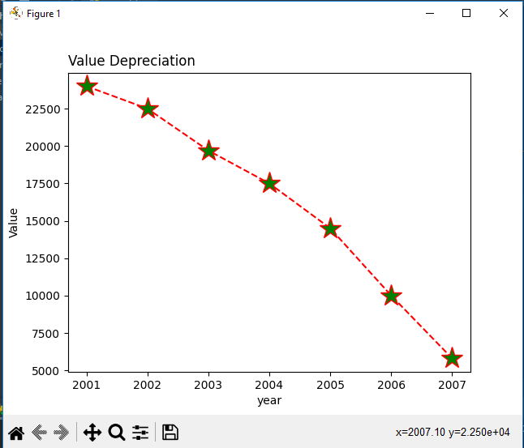

2. Following table gives the daily sales of the following items in a shop

Day Mon Tues Wed Thurs Fri

Drinks 300 450 150 400 650

Food 400 500 350 300 500

Use subplot function to draw the line graphs with grids(color as blue and line style dotted) for the

above information as 2 separate graphs in two rows

a) Properties for the Graph 1:

• X label- Days of week

• Y label-Sale of Drinks

• Title-Sales Data1 (right aligned)

• Line –dotted with cyan color

• Points- hexagon shape with color magenta and outline black

b) Properties for the Graph 2:

• X label- Days of Week

• Y label-Sale of Food

• Title-Sales Data2 ( center aligned)

• Line –dashed with yellow color

• Points- diamond shape with color green and outline red

import matplotlib.pyplot as plt  
import numpy as np  
xpoints=np.array(['Mon','Tues','wed','Thurs','Fri'])  
ypoints=np.array([300,450,150,400,650])  
plt.subplot(1,2,1)  
plt.grid(color = 'blue', linestyle = 'dotted')  
plt.title("Sales Data1",loc='right')  
plt.plot(xpoints,ypoints,linestyle='dotted',color='c',marker='h',mfc='m',mec='k')  
ypoints=np.array([400,500,350,300,500])  
plt.subplot(1,2,2)  
plt.title("Sales Data2",loc='center')  
plt.plot(xpoints,ypoints,linestyle='dashed',color='y',marker='d',mfc='g',mec='r')  
plt.grid(color = 'blue', linestyle = 'dotted')  
plt.show()

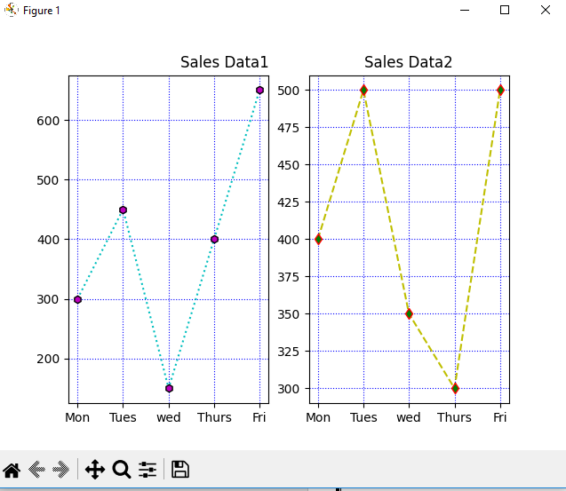

3.Create scatter plot for the below data:(use Scatter function)

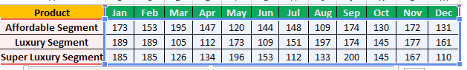

Create scatter plot for each Segment with following properties within one graph

* X Label- Months of Year with font size 18
* Y-Label- Sales of Segments
* Title –Sales Data
* Color for Affordable segment- pink
* Color for Luxury Segment- Yellow
* Color for Super luxury segment-blue

import matplotlib.pyplot as plt  
import numpy as np  
xpoints=np.array(['Jan','feb','Mar','Apr','May','jun','jul','Aug','Sep','Oct','Nov','Dec'])  
ypoints=np.array([173,153,195,147,120,144,148,109,174,130,172,131])  
plt.scatter(xpoints,ypoints,color='hotpink')  
ypoints=np.array([189,189,105,112,173,109,151,197,174,145,177,161])  
plt.scatter(xpoints,ypoints,color='yellow')  
ypoints=np.array([185,185,126,134,196,153,112,133,200,145,167,110])  
plt.scatter(xpoints,ypoints,color='blue')  
plt.show()

output

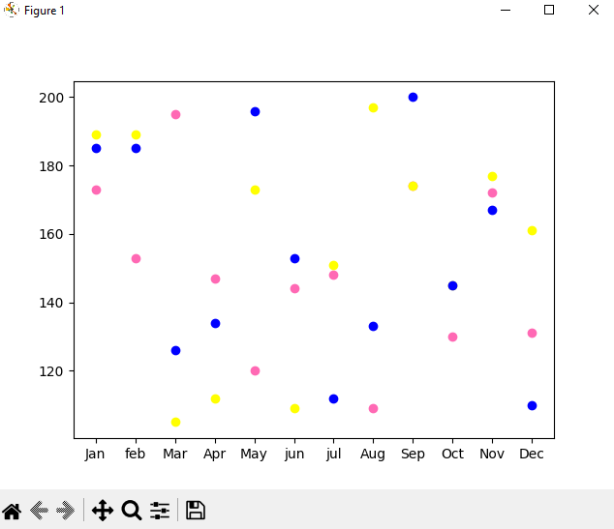

4.Display the above data using multiline plot( 3 different lines in same graph)

* Display the description of the graph in upper right corner(**use legend())**
* Use different colors and line styles for 3 different lines

import matplotlib.pyplot as plt  
import numpy as np  
xpoints=np.array(['Jan','feb','Mar','Apr','May','jun','jul','Aug','Sep','Oct','Nov','Dec'])  
ypoints=np.array([173,153,195,147,120,144,148,109,174,130,172,131])  
plt.plot(xpoints, ypoints, label = "line 1", linestyle="-")  
ypoints=np.array([189,189,105,112,173,109,151,197,174,145,177,161])  
plt.plot(xpoints, ypoints, label = "line 1", linestyle=":")  
ypoints=np.array([185,185,126,134,196,153,112,133,200,145,167,110])  
plt.plot(xpoints, ypoints, label = "line 1", linestyle="--")  
plt.legend()  
plt.show()

output

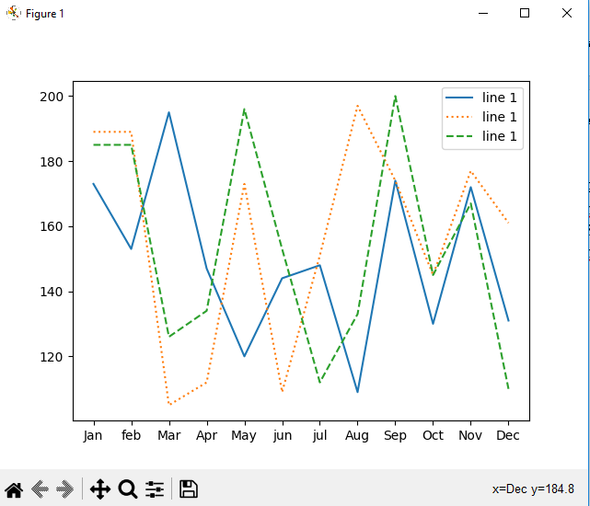

5.100 students were asked what their primary mode of transport for getting to school was. The results of this survey are recorded in the table below. Construct a bar graph representing this information.

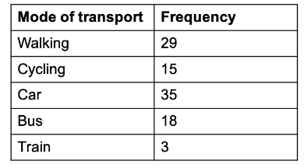

Create a bar graph with

* X axis -mode of Transport and Y axis ‘frequency’
* Provide appropriate labels and title
* Width .1, color  green

import matplotlib.pyplot as plt  
import numpy as np  
  
xpoints=np.array(['Walking','Cycling','Car','Bus','Train'])  
ypoints=np.array([29,15,35,18,3])  
  
plt.xlabel("Mode Of transport")  
plt.ylabel("Frequency")  
plt.title("Transport Data",loc='left')  
  
plt.plot(xpoints,ypoints,linewidth=1,color='g')  
plt.show()

output

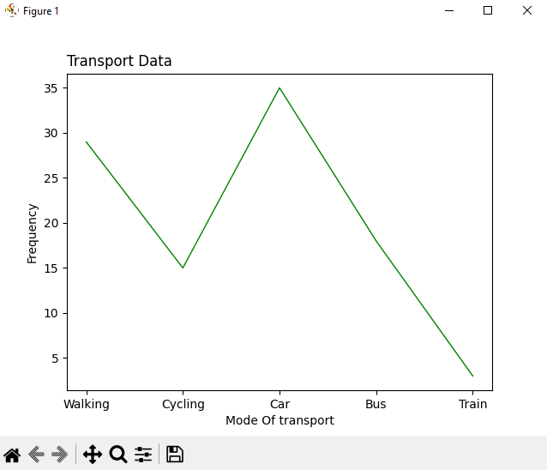

6.We are provided with the height of 30 cherry trees.

 The height of the trees (in inches): 61, 63, 64, 66, 68, 69, 71, 71.5, 72, 72.5, 73, 73.5, 74, 74.5, 76, 76.2, 76.5, 77, 77.5, 78, 78.5, 79, 79.2, 80, 81, 82, 83, 84, 85, 87.Create a histogram with a bin size of 5

import matplotlib.pyplot as plt  
import numpy as np  
  
xpoints=np.array([ 61, 63, 64, 66, 68, 69, 71, 71.5, 72, 72.5, 73, 73.5, 74, 74.5, 76, 76.2,  
76.5, 77, 77.5, 78, 78.5, 79, 79.2, 80, 81, 82, 83, 84, 85, 87])  
  
plt.hist(xpoints,bins=5, edgecolor="yellow", color="green")  
plt.show()

output

